A Project Report On

**Airline Delay And Cancellation**

*Submitted By*

Sumit Bansod(PL)

(220940325081)

Saurav Sharma

(220940325063)

Dipti Patil

(220940325028)

Keshav Yawale

(220940325036)

Gauri Pandey

(220940325033)

Guided by

Vineeta Singh,CDAC Kharghar

*In partial fulfilment of*

*the requirements for the award of the degree of*

Post Graduate Diploma

In

Big Data Analytics

(PG-DBDA)



Year 2022-23

Abstract

The airline industry is prone to delays, which can cause significant inconvenience for passengers and incur costs for airlines. This project report aims to analyze airline delay data to identify patterns and trends and suggest strategies to improve operational efficiency and reduce delays.

The project uses a combination of regression analysis, machine learning, and network analysis to analyze a large dataset of airline delay data. The dataset includes information on flight schedules, arrival and departure times, weather conditions, and airline operations.

The analysis reveals several key findings, including the most common causes of delays, the airlines and airports with the highest delay rates, and the impact of weather on delays. Based on the analysis, the report suggests several strategies for reducing delays. The report also recommends further research to explore the impact of other factors

Overall, the project report provides valuable insights into the complex factors that contribute to airline delays and suggests strategies for improving operational efficiency and reducing delays in the airline industry.

Table of Contents

1. Introduction …………….………………………………………………….04

2. Research Motivation …………………………………….…………...05

3. Problem Statement ……………………………………….…………..06

4. Project Development ………………………………………………...07

5. Methodology ……………………………….……………………………..08

6. Conclusion ………………………………………………………………..…... 24

1. Introduction:

Passengers may experience difficulty and annoyance as a result of airline delays, which can also have a large financial impact on airlines and airports. So, in order to enhance their operations and cut down on delays, airlines and airports must examine delay data and find patterns and trends.

The information on flight schedules, actual departure and arrival times, the causes of delays, and other pertinent details were gathered from a major airline for inclusion in this report. The information contains both domestic and international flights throughout the course of a year..

The report will start off by giving a general overview of the data and the analysis techniques. The analysis' findings, including information on delay lengths and causes of delays, will subsequently be presented. On the basis of the analysis, the report will then offer potential options for minimising delays.

The overall goal of this project is to offer useful insights on airline delays as well as offer workable solutions for enhancing airline operations and decreasing passenger delays.

2. Research Motivation:

Airline delays can cost the company money, raise operating expenses, and harm its brand. Moreover, delays may cause customers to be less satisfied, which may ultimately harm an airline's bottom line. This airline delay and analysis project report was created with the goal of addressing an important problem in the aviation sector: airline delays. In addition to annoying passengers, flight delays have a major financial impact on both airlines and airports.

This project report intends to offer insights into potential solutions for minimising delays and enhancing the overall passenger experience by examining airline delay data and identifying factors that lead to delays. The results of this study can be used by airports and airlines to make data-driven decisions and implement operational changes that will shorten wait times and increase customer satisfaction. Also, the report's conclusions and suggestions may assist airlines in enhancing their productivity and competitiveness, which is crucial in the fiercely competitive aviation sector.

In order to address this pressing issue in the aviation sector and to offer workable solutions for minimising delays, strengthening operations, and improving the overall passenger experience, this airline delay and analysis project report was inspired.

3.Problem Statement:

Airline Delay and Cancellation is a pervasive problem in the aviation industry that affects not only travelers, but also airlines and airport operators.. Our aim is to create an effective and informative visual representation of flight delay and cancellation data for major US airlines, to identify patterns and insights that can improve air travel. This will benefit airlines, airports, and passengers by better understanding the factors contributing to delays and cancellations.We'll be using exploratory analysis and machine learning models to predict airline departure and arrival delays.

4.Project development:

An overview of the data mining and data modelling process, from data collection to data preparation to data modelling, is provided in this section. According to numerous data scientists, data cleaning and formatting can be thought of as the most important element of the entire project. Figure below illustrates how algorithms used in data mining to extract knowledge from a dataset work.

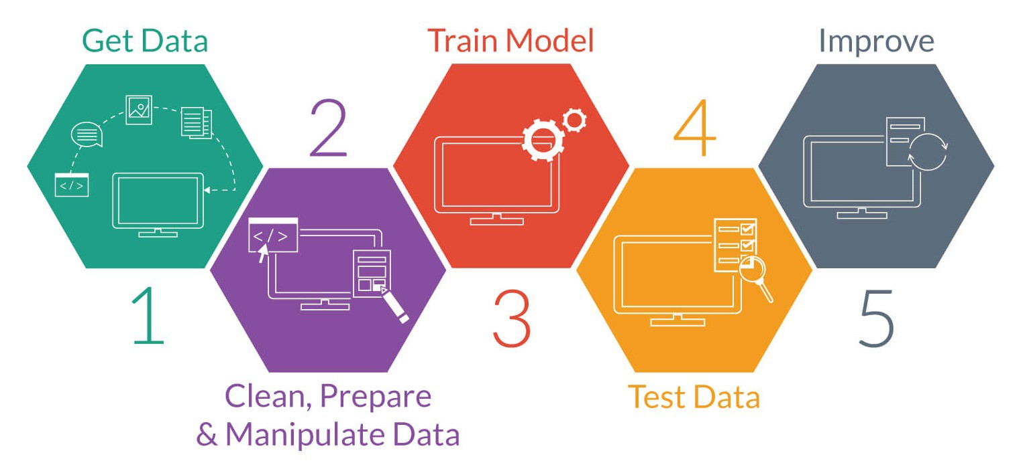

5 . Methodology



Technologies used:

1. Apache Spark

2. Apache Spark MLlib

3. Apache Spark SQL

4. PowerBI

A.Data sources:

The data source that we have in the is analysis is a dataset

from Kaggle which contains U.S. flight data from 2009 2018. The

rows of the dataset represent specific flights from that year, while the columns contain extensive information on the flight such as airline, flight date, departure delay, arrival delay, etc.

Each year's worth of data is contained in a CSV file, totaling about 7 GB for the complete dataset. Moreover, there are roughly 6 million rows in each file. We have decided to just use the data for the year 2018 because we will be conducting research on Anaconda Navigator , which has a RAM and GB constraint. For our EDA and modelling, this dataset with 7.2 million rows will be adequate; utilising a bigger combined dataset will greatly slow down the training of models and perhaps only slightly improve overall performance.

Below is an image of what the dataframe looks like after being read.

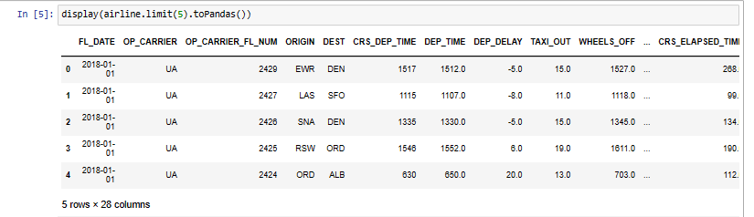

B. Data preprocessing:

Big data is a reality in our time. We’ve gathered a lot of data, allowing us to draw conclusions that are meaningful and guide business decisions.

Yet, unless it is processed and investigated, the raw data does not give much. We require a rigorous exploratory data analysis procedure in order to get the most out of raw data. We cannot simply throw the raw data to machine learning models, no matter how intricate or well-organized they are. The quality of the models depends on the data we give them. The analysis and exploration of the data get more challenging as the volume of data grows.

As a result, we must clean and change the data into an appropriate format.

1.Import necessary libraries and initialize a SparkSession:

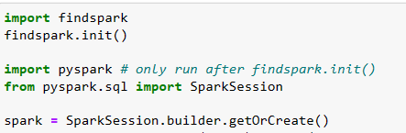

2.Read in the dataset



3.Check the schema and preview the data:



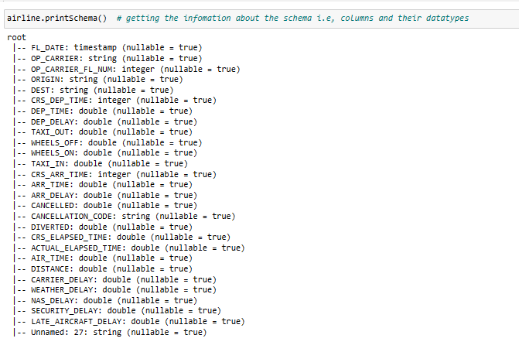

4.Convert columns to appropriate data types:

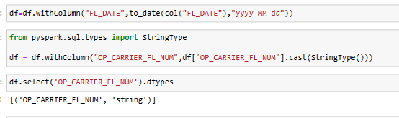

# 

# 5. Feature Transformation

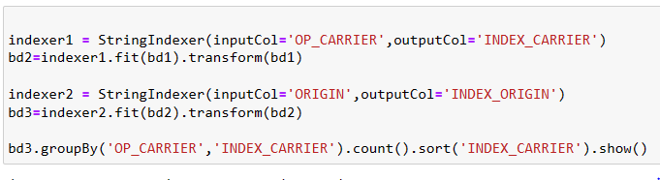

# 

# 

# 6.Feature Selection

# 

# 7. Imputing Null values

# 

C. Data Visualization:

# After our data has been cleansed, we are prepared to visualise it in order to acquire some important insights and effectively communicate our project to non-technical stakeholders..

A.Average total Delay on Arrival by Airline

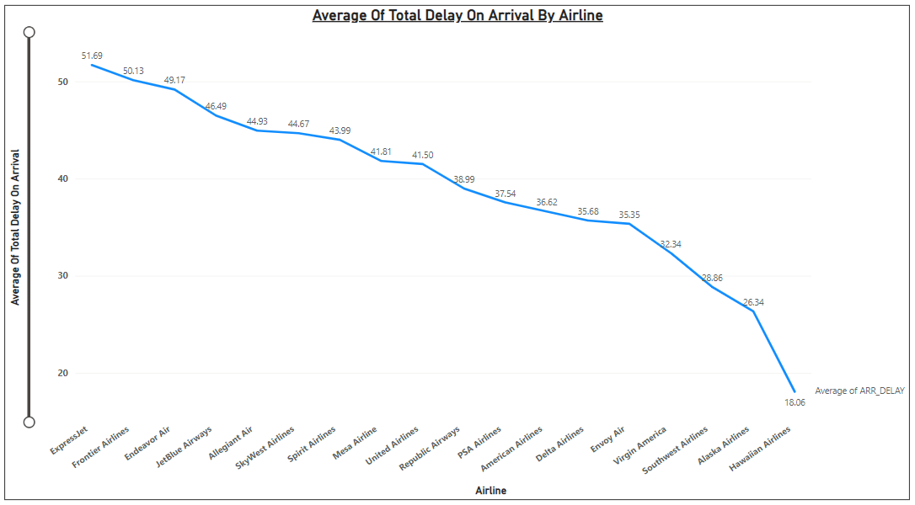

Observation:

Expressjet has an average of 51.69 which is the highest amount of average delay.

B. Average of total delay on arrival in minutes by destination

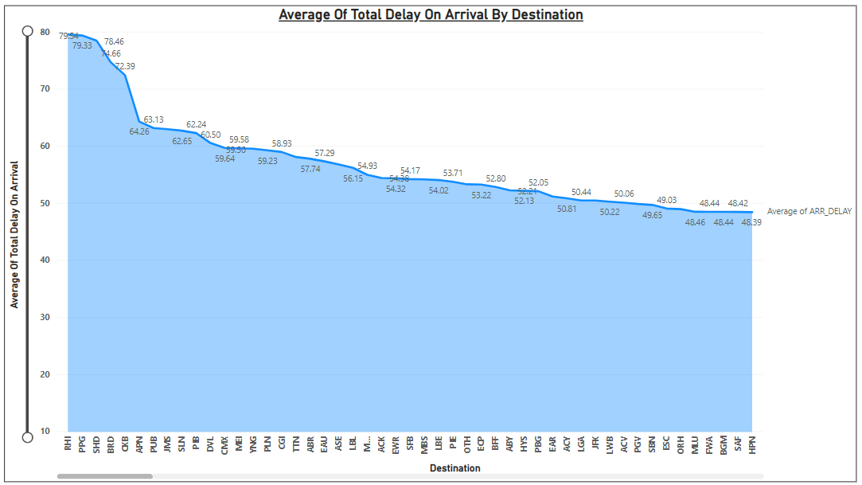

Observation:

# (RHI) Rhinelander–Oneida Country Airport has highest average of total delay on arrival in minute

C. Total Distance Travelled by Airline

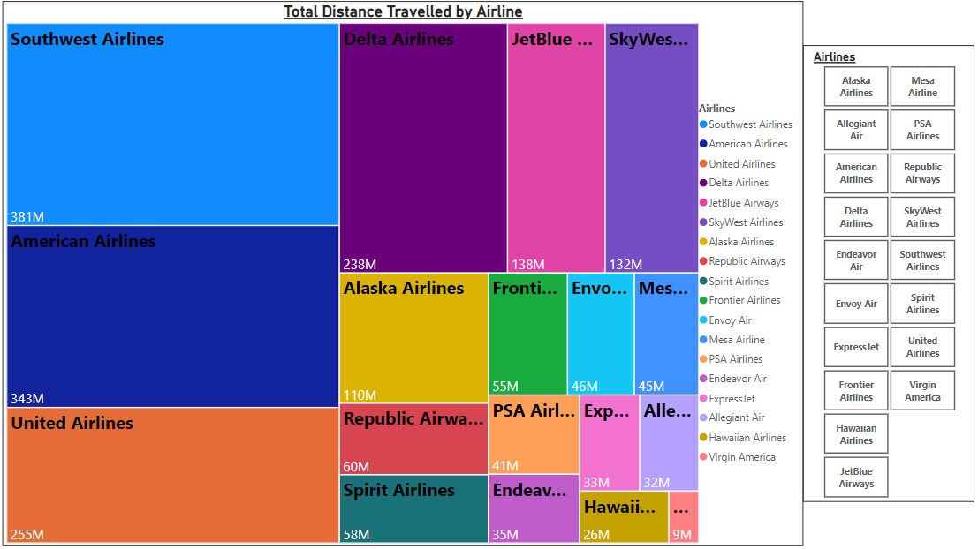

Observation:

Southwest airline cover highest distance so it is busiest airline

D. Average of actual arrival time by Airline

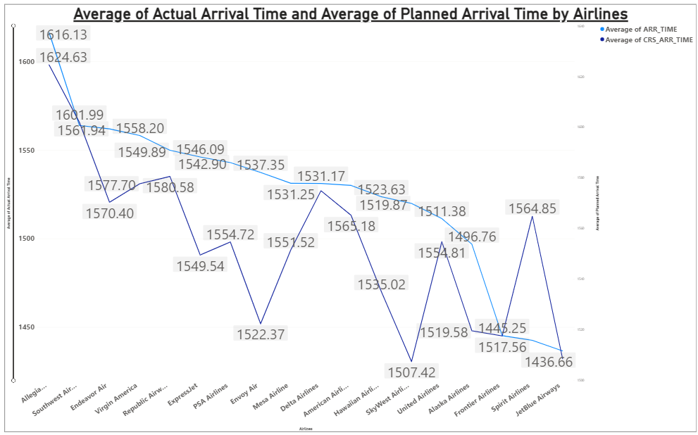

Observation:

Here we have compared Average of actual arrival time with planned arrival time

E. Busiest routes

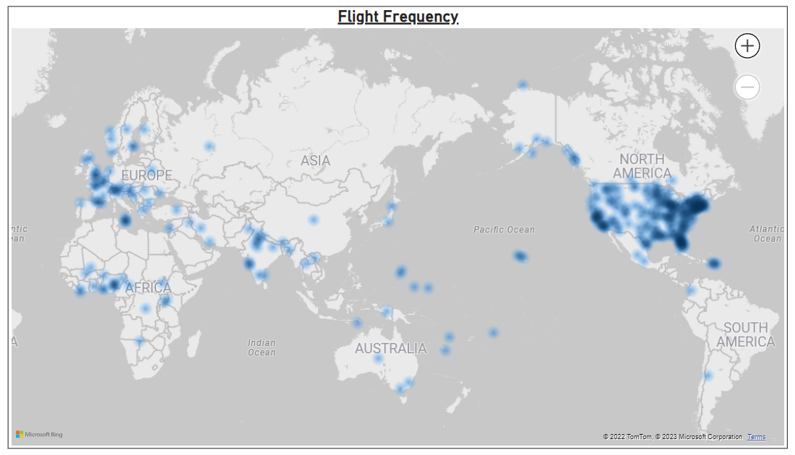

Observations:

New York, florida, London, new delhi, paris, malta, hawaii  has most number of flights running (so they are busiest route)

F. Arrival Delays

* Arrival delay month
* Arrival delay by airlines
* Arrival Delay by City
* Arrival Delay in Airlines by Time
* Median Arrival Delay By Airlines
* Median of Total Delay on Arrival and ORIGIN

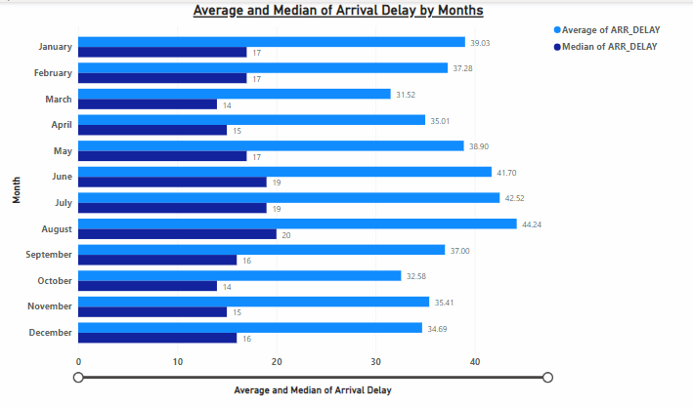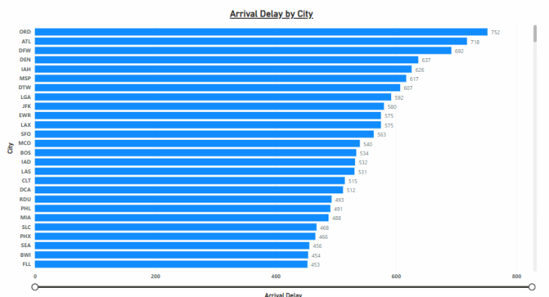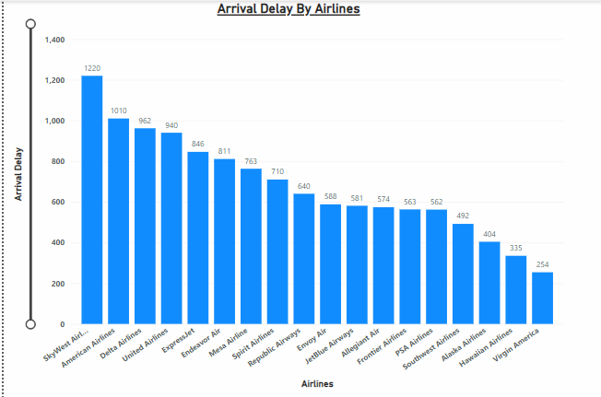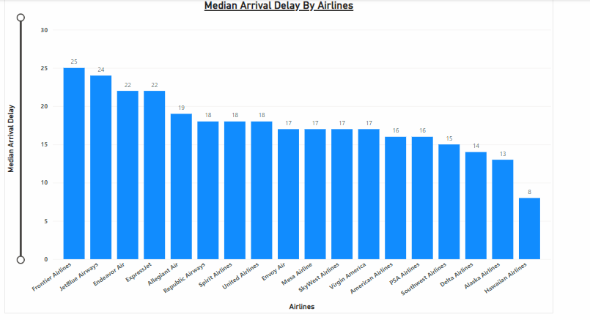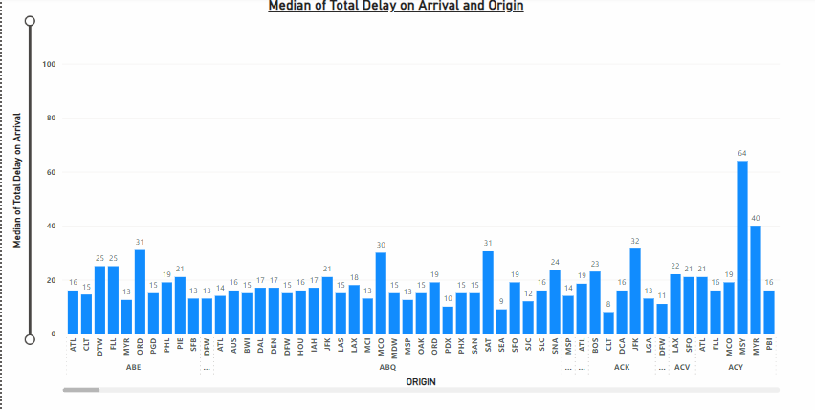

# 

# Observations:

# The month of July saw the longest arrival delays, followed by SkyWest Airlines, Ord City, and Southwest Airlines in the second quarter.The longest average arrival delay is with Frontier Airlines.

# G.Departure Delay

# Dep Delay by month

# Count of total delay on departure by Airlines

# 

# Observations:

# In July highest departure delay happen

# Southwest Airline have Highest Count of total delay on departure

# H. Cancelled Flight

# Count of flight cancelled by month

# Count of flight cancelled by Day

# Count of flight cancelled by airline

# 

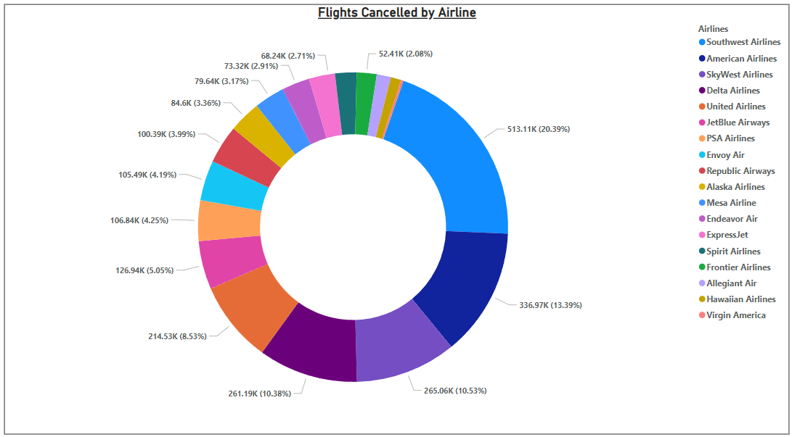

Observation:

* We are getting count of flight cancelled by month ,during July and august most amount of flights were cancelled
* We are getting count of flight cancelled by day wise , variations are in middle of month
* Southwest airline has highest % 20.39 for flight cancellation

# D. Machine learning:

**A number of machine learning algorithms, such as LOGISTIC REGRESSION, DECISION TREE CLASSIFIER, GRADIENT BOOSTING, RANDOM FOREST CLASSIFIER, and SVM, have been tested.**

**Each model ‘s F1 Score and accuracy score is calculated :**

* **LOGISTIC REGRESSION = 0.7644**
* **DECISION TREE CLASSIFIER = 0.7822**
* **GRADIENT BOOSTING = 0.8215**
* **RANDOM FOREST CLASSIFIER = 0.7809**
* **SVM = 0.5000**

# After trying out several algorithms, the most suitable algorithm for our dataset is the Gradient Boosting which is a basic but excellent algorithm for Binary Classification.

1. Split the preprocessed dataset into training and testing datasets

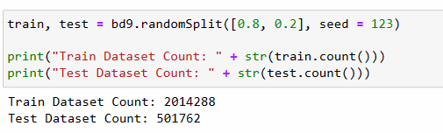

1. Import libraries which are necessary for gradient boosting

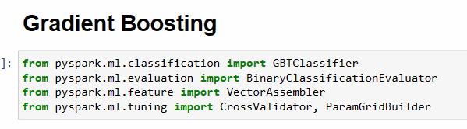

1. Applying gradient boosting model

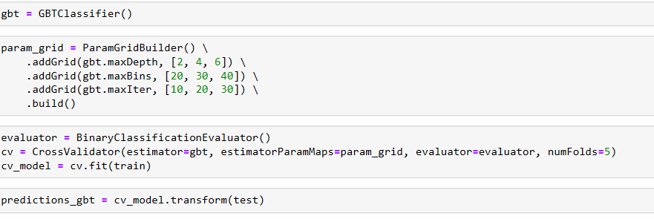

1. Check accuracy of model

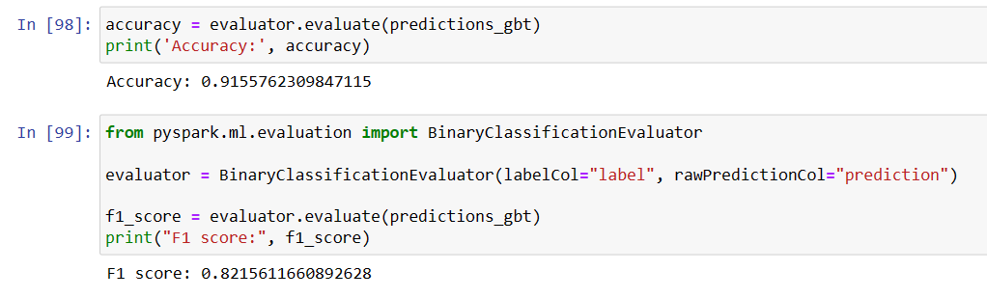

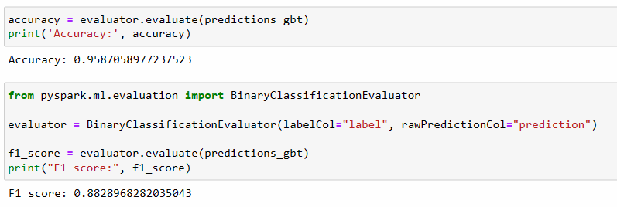

6. Conclusion:

Before anything else, we made sure that we comprehended the airline dataset, the work at hand, and the standard by which our contributions will be evaluated. Then, we carried out a rather straightforward EDA to look for connections and patterns that would support our modelling. We took the required preprocessing steps along the way, including indexing categorical variables, imputed missing values, and scaled features to a range. Then, in an effort to improve our model, we built new features using the data that was already available.

After that, we have visualised the data using preprocessed data. Expressjet has the largest average delay, at 51.69, in the industry. (RHI) The average total delay on arrival at Rhinelander-Oneida County Airport is the greatest per minute. The most flights are operating in New York, Florida, London, New Delhi, Paris, Malta, and Hawaii (so they are the busiest routes). The majority of flights were cancelled in July and August, according to data on cancelled flights by month. According to data on cancelled flights by day, changes in cancellation rates occur in the middle of a month. Southwest Airlines has the highest cancellation rate (20.39%). Also, we came to the conclusion that monsoon season, which itself may cause aircraft delays, is when flights are most frequently delayed.

Then, in order to determine if flights will be delayed or not in 2018, we implemented several classification models i.e, Logistic Regression Model, Decision tree classifier, Gradient Boosting, Random forest and SVM model where Gradient boosting is the most appropriate model and has an accuracy rate of 91.55% .